Setup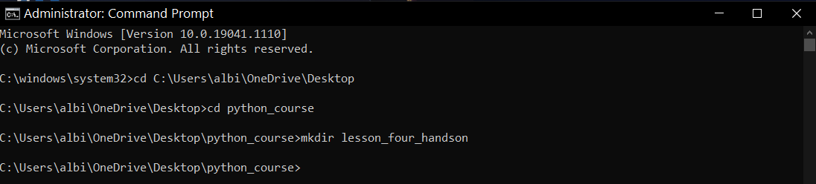

## Requirements

This hands-on is broken into three parts. Please complete each part within your main.py file.

## Part 1

1. Create two dictionaries to represent information about two pets. Each dictionary should contain the following information (different for each pet):

* Pet's Name (This should be the name of your dictionary)
* Type of Pet
* Color
* Nickname
* Owner's Name

1. Iterate over each dictionary, printing each key-value pair on one line. The output should be similar to the below:

Type: Cat

Color: White and Orange

Nickname: Birchy

Owner: Kurt

Type: Cat

Color: Tortoise Shell

Nickname: Palnut

Owner: Olivia

Python Commands:

Leonard = {

"Type": "Cat",

"Color": "Black & White",

"Nickname": "Lenny",

"Owner": "Ewa & Jan"

}

print(Leonard)

Misha = {

"Type": "Cat",

"Color": "Black & Brown",

"Nickname": "Mishka",

"Owner": "Basia & Everett"

}

print(Misha)

for key,value in Leonard.items():

print(key,":",value)

for key,value in Misha.items():

print(key,":", value)

Results:

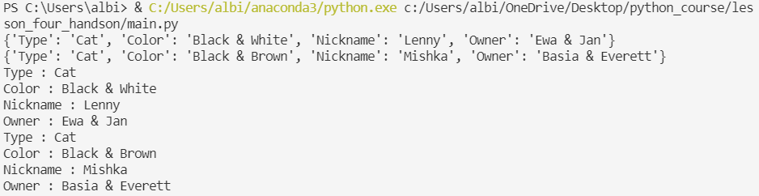

## Part 2

1. Add three new dictionaries to your program.

* Each dictionary should represent a city around the world.

1. Add the below dictionaries to your main.py file:

england = {'Capital': 'London'}

france = {'Capital': 'Paris'}

belgium = {'Capital': 'Brussels'}

1. Given the above dictionaries, add the following information to each dictionary:

* Population
  + The population of England is 53.01 million
  + The population of France is 66.9 million
  + The population of Belgium is 11.35 million
* Interesting Fact
* Top Language Spoken by Locals

1. Once you have added the necessary information into the dictionaries, loop through each one and print out all key-value pairs.

Python commands:

bulgaria = {"Capital": "Sofia"}

spain = {"Capital": "Madrid"}

denmark = {"Capital": "Copenhagen"}

england = {"Capital": "London"}

france = {"Capital": "Paris"}

belgium = {"Capital": "Brussels"}

bulgaria["population in millions"] = 7

spain["population in millions"] = 46.94

denmark["population in millions"] = 5.81

england["population in millions"] = 53.01

france["population in millions"] = 66.9

belgium["population in millions"] = 11.35

bulgaria["interesting fact"] = "Bulgarian roses are used to make French perfumes."

spain["interesting fact"] = "Spanish people discovered oranges and chocolate."

denmark["interesting fact"] = "Denmark is considered the happiest country in the world."

england["interesting fact"] = "Sparkling wine was invented in England."

france["interesting fact"] = "French people invented the hot air balloon."

belgium["interesting fact"] = "Belgians invented french fries and eat them with mayo."

bulgaria["top language"] = "Bulgarian"

spain["top language"] = "Spanish"

denmark["top language"] = "Danish"

england["top language"] = "English"

france["top language"] = "French"

belgium["top language"] = "Dutch (and others)"

print(bulgaria)

print(spain)

print(denmark)

print(england)

print(france)

print(belgium)

for key,value in bulgaria.items():

print(key,":", value)

for key,value in spain.items():

print(key,":", value)

for key,value in denmark.items():

print(key,":", value)

for key,value in england.items():

print(key,":", value)

for key,value in france.items():

print(key,":", value)

for key,value in belgium.items():

print(key,":", value)

Results:

>>> spain = {"Capital": "Madrid"}

>>> denmark = {"Capital": "Copenhagen"}

>>> bulgaria["population in millions"] = 7

>>> spain["population in millions"] = 46.94

>>> denmark["population in millions"] = 5.81

>>> england["population in millions"] = 53.01

>>> spain["interesting fact"] = "Spanish people discovered oranges and chocolate."

>>> denmark["interesting fact"] = "Denmark is considered the happiest country in the world."

>>> england["interesting fact"] = "Sparkling wine was invented in England."

>>> france["interesting fact"] = "French people invented the hot air balloon."

>>> denmark["top language"] = "Danish"

>>> england["top language"] = "English"

>>> france["top language"] = "French"

>>> belgium["top language"] = "Dutch (and others)"

>>> print(spain)

{'Capital': 'Madrid', 'population in millions': 46.94, 'interesting fact': 'Spanish people discovered oranges and chocolate.', 'top language': 'Spanish'}

>>> print(denmark)

{'Capital': 'London', 'population in millions': 53.01, 'interesting fact': 'Sparkling wine was invented in England.', 'top language': 'English'}

>>> print(france)

{'Capital': 'Paris', 'population in millions': 66.9, 'interesting fact': 'French people invented the hofries and eat them with mayo.', 'top language': 'Dutch (and others)'}

>>> for key,value in bulgaria.items():

... print(key,":", value)

...

population in millions : 7

interesting fact : Bulgarian roses are used to make French perfumes.

top language : Bulgarian

>>> for key,value in spain.items():

... print(key,":", value)

...

Capital : Madrid

population in millions : 46.94

interesting fact : Spanish people discovered oranges and chocolate.

top language : Spanish

>>> for key,value in denmark.items():

... print(key,":", value)

...

Capital : Copenhagen

population in millions : 5.81

interesting fact : Denmark is considered the happiest country in the world.

top language : Danish

>>> for key,value in england.items():

... print(key,":", value)

...

Capital : London

population in millions : 53.01

interesting fact : Sparkling wine was invented in England.

top language : English

>>> for key,value in france.items():

... print(key,":", value)

...

Capital : Paris

population in millions : 66.9

interesting fact : French people invented the hot air balloon.

top language : French

>>> for key,value in belgium.items():

... print(key,":", value)

...

Capital : Brussels

population in millions : 11.35

interesting fact : Belgians invented french fries and eat them with mayo.

top language : Dutch (and others)

## Part 3

1. Add a dictionary to your program that replicates a user's pizza order. Name this dictionary pizza_order and it should contain the following:

* Customer's Name
* What size pizza they have ordered
* What type of crust
* What toppings they would like.
  + Toppings should include at least three separate toppings

1. Next, print out the customer's order:

* Thank them for their order using their name
* Print out what they're ordering
* Print out the list of toppings (minimum 3)

1. Your output should looks similar to the following:

Thank you for your order, Andrew

You have ordered a small, thin-crust pizza with the following toppings:

extra cheese, sausage, bacon

* Use the print() and get() functions

Python commands:

pizza_order = {

"Customer's name": "Albi",

"Pizza size": "12 inch",

"Crust type": "thin-crust",

"Toppings": "peperoni, mushroom, onion, olives, green pepper, tomato, garlic, and basil"

}

print(pizza_order)

print(

"Thank you for your order, " +

pizza_order.get("Customer's name") +

"\nYou have ordered a " + pizza_order.get("Pizza size") +

", " + pizza_order.get("Crust type") +

" pizza with the following toppings:" +

"\npeperoni, mushroom, onion, olives, green pepper, tomato, garlic, and basil"

)

Results:

